PROJECT ON

**BLOCKCHAIN TECHNOLOGY IN MILITARY APPLICATIONS**

SUBMITTED TO: DR. DURGANSH SHARMA

SUBMITTED BY:

|  |  |  |  |  |
| --- | --- | --- | --- | --- |
| **S. No.** | **NAME** | **SAP ID** | **ROLL NO** | **BATCH** |
| 1. | RIBHU RISHI | 5000 | 44 | B2 |
| 2. | SANSKAR DUA | 500066533 | 48 | B2 |
| 3. | ROHAN RATHORE | 500071555 | 84 | B2 |
| 4. | NITIN KUMAR | 500071821 | 88 | B2 |

INDEX

|  |  |  |
| --- | --- | --- |
| S No. | Content Name | Page No. |
| 1. | Introduction | 3 |
| 2. | Possible Implementation in Military Applications | 4 |
| 3. | Objectives | 5 |
| 4. | Outcomes | 6 |
| 5. |  |  |
| 6. |  |  |

INTRODUCTION

**Blockchain** is a technology that is used as a basic structure for operation and control of modern digital transactions. It is representation of financial ledger entry, otherwise record of transactions taking place. All the transactions that take place contain a digital signature to ensure its authenticity, so that no one could temper with the data on the Blockchain. This technology allows digital information to be distributed and shared, but not to be copied. This in turn means that each individual possesses a defined portion of data that can only have one owner.

Any new information/data on Blockchain is added into the database, which is stored at multiple locations and updated at regular interval. It makes the data to be public and verifiable. Since there is no data centralization, it is extremely harder to bruteforce as the information exists simultaneously in millions of places at a given point of time.

POSSIBLE IMPLEMENTATION IN MILITARY APPLICATIONS

1. Preventing data theft.
2. Secure Government and Battlefield Messaging.
3. Tracking Defence shipments/contracts in real-time.
4. Military Manufacturing and processing.
5. Cyber Warfare Preparedness.
6. Maintaining health record of defence personnel.
7. Coordinated control over sophisticated weapons and ordinances.

OBJECTIVES

Following are the objectives of this project:

1. Implementing this project in order to facilitate a transparent and multi-user controlled database.
2. Brining up a notion of a single data record in order to avoid any redundancy and ambiguity.
3. Distributed Peer-to-peer connection allows sharing of data with all the users at the same time.
4. Data once sent to a Blockchain network, cannot be deleted or removed from all the systems, preventing deletion of data from one source.
5. It will improve the overall data collection by removing any duplicates from the database.
6. Attacking on distributed storage is far more complex and difficult than when compared to centralized databases.
7. It allows users to interact with each other directly without any necessity of a mediating third-party.

OUTCOME

Following are the outcome of this project:

1. Decentralization: Since the data on Blockchain is distributed among all the participating users, it makes data more secure and recoverable.
2. Resilience: It will improve the capability of data to be secure in case of a massive attack.
3. Transparency: This technology allows all the peers to view the detail of transactions taking place on this network.

SRS (Software Requirement Specifications)

1. OS: Windows 10 or later
2. RAM: 2GB (Optimal)

4GB (Recommended)

1. Storage: 500GB
2. Internet Connectivity
3. Basic Input and Output devices

DATA SECURITY

DECENTRALISED DATA STORAGE

PERMANENT AVAILABILITY OF DATA

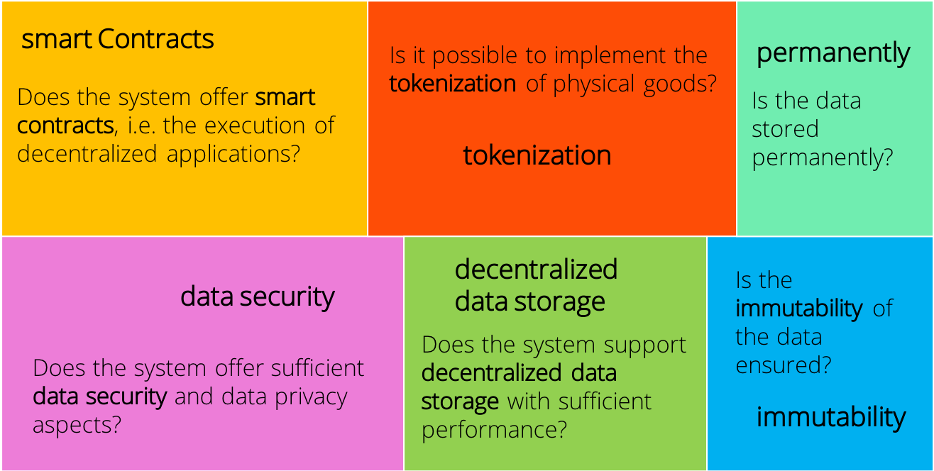

HEALTH APPLICATION

* EHRs(Electronic health records)
* Prescription traceability
* Data access control

**Individuals and interactions over processes and tools:**

In this project we will be implementing the concept of interaction with each and every individual working on this project over every process and the tools we will be using. Moreover, decisions made during this project will be according to every individual’s perspective.

**Working software over comprehensive documentation:**